Worksheet - How Blockchain Produces Integrity
Week 2, Session 1 | Assessment 2 (A2) - the weekly worksheets | You submit this yourself
Complete it in class and submit it on Moodle before you leave.
Your details (not marked)
Full name | Meqdad Muhana
Student ID | 202306213
Today's partner / group | Ali Mohammed Radhi - 202304871
How this worksheet works
• This worksheet counts towards Assessment 2. You complete and submit it yourself, even when you work with others.
• Write your answers in your own words, and list any sources you used in Task 4.
Words to know
These are the words this worksheet uses. You are not marked on the definitions themselves, only on using the ideas.
Term | Plain meaning
Transaction | One instruction to move value from one holder to another, and the record of that move.
Block | A batch of transactions added to the record book in one go. Each block is locked to the block that came before it.
Blockchain | A shared record book that many computers keep a copy of at the same time. New entries are added in batches called blocks. Each batch is locked to the one before it. No single owner can quietly change an entry that is already in.
On-chain | Recorded on the blockchain itself, so anyone with access can see it and nobody can quietly change it.
Tamper-evident | Built so that any change to an old record shows up at once. It does not stop someone trying. It makes the attempt impossible to hide.
Cryptography | The mathematics of scrambling and of proving. Here it is used to prove who authorised something, and to show whether data has been changed since it was written.
Consensus | The method a network uses to agree which version of the record book is the real one. It is needed because several computers could each add the next block.
Coin | A token that belongs to a blockchain's own record book and is used to pay that network's fees. Bitcoin and ether are coins.
Counterparty | The firm or person on the other side of a deal from you.
Task 1 - From the reading
Answer the guiding questions from the structured extract.
Expected: 2-3 sentences per question.
Q1. Why does linking blocks by hash make tampering visible?
Linking blocks by a cryptographic hash makes tampering instantly visible because a hash acts as a unique digital fingerprint for a block's specific data. If someone alters even a single character in a past block, its hash changes completely, which immediately breaks the mathematical link to the subsequent block that stored the original hash. This chain reaction of mismatched fingerprints alerts the entire network that the historical record has been modified.
Q2. What does a digital signature prove, and what does it NOT prove?
A digital signature mathematically proves that a transaction was authorized by the holder of the specific private key associated with the sending address, demonstrating cryptographic control over the funds. However, it does not prove the real-world legal identity of the person actually holding that key, nor does it prove that the transaction was made willingly rather than under duress or by theft of the key.
Q3. Give one thing hashing cannot protect a business from.
Hashing cannot protect a business from inaccurate or fraudulent data being entered into the system in the first place, commonly known as the "garbage in, garbage out" vulnerability. While the hash definitively ensures the data remains unchanged once recorded on the distributed ledger, it provides no guarantee that the initial input was truthful, accurate, or legally valid.
Task 2 - Apply it (individual build task)
Now use the ideas from Task 1 to do this, in your own words:
A Bahraini land-registry office notarises a property record and anchors its hash on a blockchain. A year later, someone alters the stored record. What does the hash prove about this alteration - and what does it NOT prove (for example, about whether the original record was correct, or who made the change)?
Expected: 3-5 sentences.
When the altered property record is hashed, it will produce a completely different cryptographic fingerprint than the original hash anchored on the blockchain by the Bahraini land-registry office, definitively proving that the document has been tampered with since its notarisation. However, this mathematical mismatch does not prove who made the unauthorized alteration, nor does it provide a mechanism to automatically restore the deleted original data. Furthermore, while the original hash proves the document existed in a specific state at that exact time, an alternative explanation is that the original notarised document itself could have contained factual errors before being anchored. Therefore, while blockchain secures the integrity of the data at rest, it relies entirely on off-chain institutional trust to ensure the accuracy of the property details at the point of origin.
Task 3 - Group activity (your own write-up)
Trace the transaction.
In pairs, trace one transaction through the five steps; each completes their own trace, then present one step to the class.
• Who signs, and with what?
• Who verifies, and against what rules?
• Who appends it to a block?
• Who broadcasts it to the network?
• What makes it hard to reverse later?
Expected: complete the activity above, then write your own answer of about half a page.
Write your own answer here:
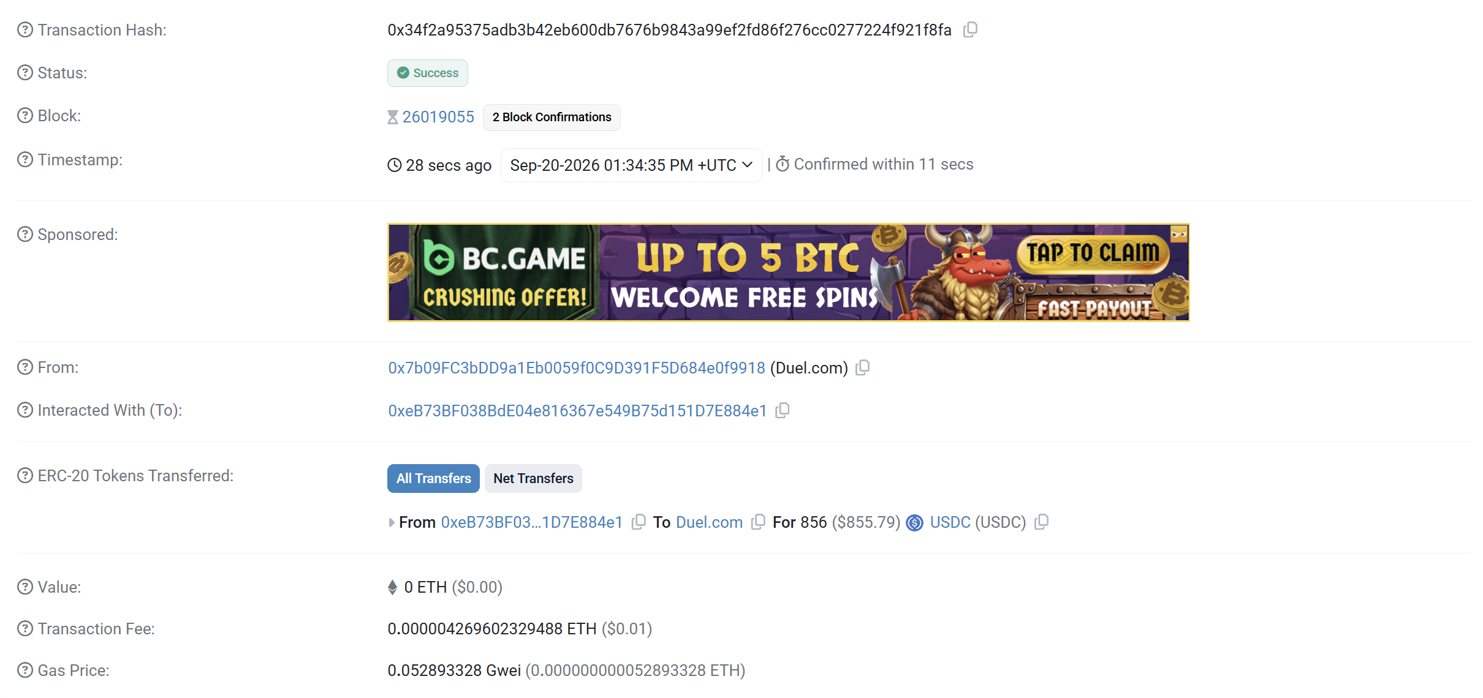
To trace a blockchain transaction from initiation to finality, we must follow a strict sequential mechanism that distributes trust across the network without relying on a central intermediary. First, the sender initiates the transaction and signs it using their cryptographic private key. This signature acts as a mathematical proof of control over the specific blockchain address, ensuring that only the rightful owner can authorize the movement of the asset. Secondly, once the transaction is transmitted to the network, individual nodes independently verify it against the protocol's strict rules. These nodes check that the digital signature is valid and that the sender's address actually holds sufficient unspent funds to complete the transfer, automatically discarding any invalid or malicious requests.
Thirdly, after passing this independent verification, a specialized node—often called a miner or a validator, depending on the consensus mechanism—selects the transaction from the memory pool (mempool) and appends it to a newly proposed block alongside other pending transactions. Fourthly, this validator then broadcasts the completed block to the entire network so that all other nodes can independently audit the block's validity before adding it to their own local copies of the shared ledger.
Finally, what makes the transaction exceptionally hard to reverse later is the system of cryptographic hashing and accumulated block confirmations. Because each block contains the hash of the preceding one, reversing this specific transaction would require an attacker to rewrite its block and every single block added subsequently. Weighing this evidence, the deeper a transaction is buried in the chain, the more computationally impossible it becomes to alter. However, it is crucial to evaluate the limits of this system: while it perfectly protects the on-chain integrity of the transfer and eliminates the cost of verifying the network state, it cannot guarantee that the off-chain business agreement tied to the transaction was actually fulfilled.
Task 4 - Sources
Sources I used (if any) | Week 2, Session 1 Structured Extract and Course Slides and notes.  https://etherscan.io/tx/0x34f2a95375adb3b42eb600db7676b9843a99ef2fd86f276cc0277224f921f8fa  Drescher (2026) Blockchain basics (2nd ed.) and European Union Blockchain Observatory and Forum (2024).
Before you submit
• Your name and student ID are filled in.
• All tasks are attempted.
• Submit this sheet before you leave today, to the Week 2 weekly worksheets link on Moodle. That same link takes both of the Week 2 weekly worksheets, one per session.
• If you need more time, finish it at home and submit to the same link by Friday 25 September 2026, 23:59. That is the deadline for both Week 2 sheets.
• Both weekly worksheets are marked together in one Week 2 marking sheet worth 1.00 percent of the course.
• You may use your notes and the session readings. Every worksheet is your own work.

